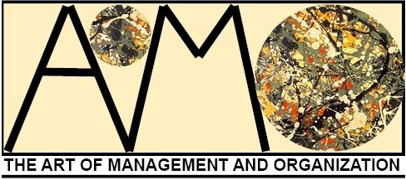

Art of Management and Organization
Company No. 8432454

Company Report: 05th October 2016

Statement of aims:

September 2002 saw the birth of The Art of Management and Organization Conference on London’s legendary South Bank. Its aim was, and continues to be, the exploration and promotion of the arts (in the most inclusive sense) as a means of understanding management and organizational life and its contexts. Since then the conference has continued its collaborative and open ethos in Paris (2004), Krakow (2006), Banff (2008), Istanbul (2010), York (2012), Copenhagen (2014) and Bled (2016) which has given rise to a vibrant global community of praxis – including both scholars and practitioners. Although it is primarily a refereed academic conference, it is also a place for integration – and here, we encourage new links, relationships and explorations. Previous keynotes and featured events have included rock stars, comedians, actors, poets, musicians, artists, storytellers, dancers, photographers, calligraphers and philosophers.
Organizational Aesthetics is an open access journal about how the five senses and artistry inform business, non-profit, and government organizations. We mean for both terms, aesthetics and organizational, to be understood broadly to include a range of topics. Examples are the use of arts-based methods in organizations, theoretical accounts of aesthetic phenomena in organizations such as beautiful (or grotesque) leadership, and the art about/in/behind organizations.

From 2013 we have been operating as a not for profit incorporated organization, allowing us to bring together the Art of Management & Organization Conference with the journal of Organizational Aesthetics. We are committed to creating quality spaces for scholars, artists, managers, researchers, performers and practitioners of all types to share what they do and how they think.

Since the 2015 AGM held in London the following has been achieved:

- Continued promotion of the AoMO Facebook page, growing AoMO online community presence to more than 510 ‘likes’. Most significantly, we have simultaneously used the website, mailing lists, FB and Twitter to communicate information regarding the 2016 conference.
- Ran a successful conference at the IEDC-Bled School of Management in Slovenia. Attended by 140 + delegates.
- Appointed an Artist in Residence 2016-2018 – Emmanuel Guy
- Redeveloped website
- Identified and are using an email management service provider – allows us to send high volume emails and makes us DPA complaint.
- University of Brighton have been secured as hosts for 2018 (academic lead Dr Jenny Knight). Contract signed and call for streams to be released immanently.
- Organizational Aesthetics has received 9 submissions between 1 September 2015 and 31 August 2016. Of those, 1 was an Art submissions, 4 were Practice submissions, and 4 were Theory submissions. This is down slightly from the 12 non-special issue submissions in the same time period the previous year. We also published 1 special topic piece, 2 editorials, and 2 books reviews, as well as publishing a special issue on dance (5(1)).The journal continues to have an acceptance rate of roughly 50%.

Going forward:
The success of the 2016 conference in Bled, Slovenia means that as an organisation we are under significant pressure from the community we serve to offer more in terms of financial support, development opportunities and networking events to enrich, facilitate and support the arts and management field of praxis. In order to do this, we need to evaluate where we are, what we are wanting to do and the resource implications of delivering this.

Jenna Ward

Stephen Linstead

Steven Taylor

August 31st 2015

