I’m Looking Through You: Visual Images, Photographic Research and Graffiti

Convenors: Garance Maréchal, University of Liverpool
Shawn Sobers, University of the West of England
Thomas Davis, University of Liverpool

‘The gap between image and lived experience is the space in which both dreams and ideas are created’
(Lippard, 1997: 76).

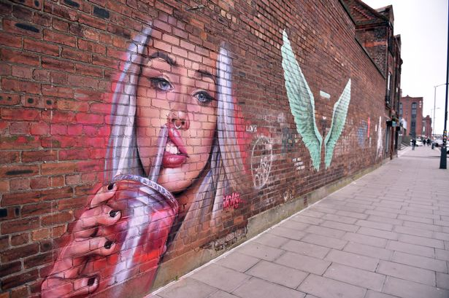
Baltic Triangle. Graffiti on Jamaica street. Picture Jason Roberts

From Georgian architecture to fine Victorian buildings, pubs with distinctive interiors, warehouse conversions, galleries and museums including the Bluecoat, the Walker Gallery and the Tate, central pedestrian Liverpool is packed with architectural and artistic spaces of visual beauty. In summer 2020, the many installations of the Biennial will add more artful spaces to these existing institutionalised ones, across the city and in often unlikely places such as disused buildings otherwise closed to the public, a bombed church, a former brewery, a warehouse, or outside in the street…

Activist art attempts to provide alternative images that differ from material objects displayed in galleries or museums. A lot of the art in Liverpool is already on the streets, with purpose and message, expressed by colourful street entertainers, Superlambanana sculptures and Assemble’s Granby Four Streets project in Toxteth – which won the Turner Prize in 2015. Liverpool’s distinctive and political socio-aesthetics is also materialised on city walls of the Baltic triangle - a regeneration area - in a way that illustrates the contradictions of the collaborative and hybrid cultural formulations of art activism (González and Posner, 2006). There, the spatial and temporal artistic interventions expressed in murals and wall graffiti have become contested sites of political struggle between corporate interests, public bodies, a variety of audiences, individual proponents of counterculture (skaters) and artists acting as ‘representatives’ of the local community and claiming to represent its interests. These different views are amusingly epitomised in the stories and debates surrounding the recurrent ‘defacing’ of Netflix commissioned mural ‘Our Planet’, and its re-appropriation by street culture and skaters, to the dismay of End of the Line, the community artistic group that coordinated the project.

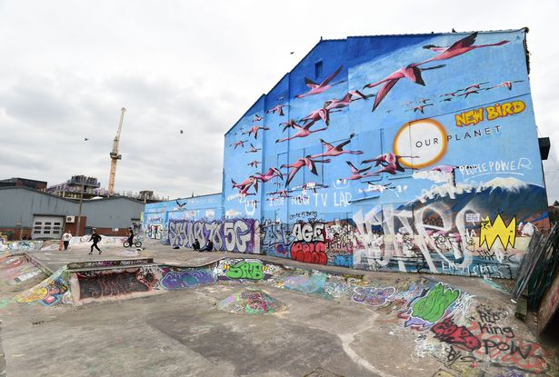
Baltic Triangle, Jamaica Street (Image: Andrew Teebay/Liverpool Echo)

This example illustrates the ways in which the ‘spirit of the street’ conveyed in often ephemeral and transitory art creations often conveys differentiated and multiple, conflicted politics of participation, inclusiveness and democratization (González and Posner, 2006). Liverpool wall graffiti is now legitimized with its own tourist trail. But one can wonder whether domesticating street art in such a way genuinely translates its original activist and communal spirit to non-local audiences, and promotes an approach to culture as being part of the lives of real people, real local neighbourhoods. Is this form of institutionalization a way to recuperate public art and transform it into ‘another rotation in the aesthetic taste system’, in this case for profit (Luke, 1996: 682)? For some, such a move is only a sign of a wider ‘cultural appropriation by developers and corporates with the connivance of so-called 'representatives' sanitising the Baltic for profit” , which erases its underground radicality.

Lippard (1984) defines activist art as a set of artful practices that challenge institutional stereotypes engaged with/in the real world, and uses public space in a community-based way that that focuses on collaboration, be it designed either ‘to weave it into or to tear apart the fabric of everyday life’ by contesting the boundaries and hierarchies emerging from contemporary social, political and economic systems (González and Posner, 2006). It aims to disrupt stereotypes and build bridges between people pitted against one another, by responding directly to social situations and by empowering the kinds of audiences that do not feel comfortable in art museums (Luke, 1996). But can it keep achieving this?

As Luke (1996: 682) interestingly notes, the relationship of activist artists to avant-gardism is a complex and contradictory one. Activist artists often pose as ‘embodiments of a transgressive and oppositional consciousness’ but their practice still struggles with achieving aesthetic legitimacy given the limited material manifestations of activist art beyond immediate communal experience. Is it art (Felshin, 1995)? To which audiences is it speaking? And what if their approach to community and communal use remains contested, when it is operating at sites where often, communities are ‘debased’?

For this stream we invite papers, art submissions, show and tell, in whichever visual medium of choice, particularly but not exclusively photography, drawing and graffiti painting that include images that express various forms of activism. We want to hear about the theory, politics, aesthetics, methods and practices behind them whether they are individual or collective productions. Show us your creative spaces as well as your creative products.

We have good contacts with local artists and creative groups, so we hope to both invite some practitioners in to talk to us and take the stream off-site for a visit to local creative spaces.
We will also have attached to the stream a photographic exhibition, The Rhythm of the Martyrs, which shows Belfast Peace Walls, murals and end of terrace artworks by peace and community activists, and musicians and artists in Northern Ireland, and features Garance’s photographs. Originally a means of marking territory between Catholic and Protestant areas, those murals started conveying political statements from the 1980s and since the Good Friday Agreement, many have been memorialised by artists or taken up for truth and justice campaigns. Liverpool has strong connections with Belfast, being the main English port with direct connections to that city, and also being the home of the White Star line, whose most famous ship was the Titanic, built in Belfast.

Send your submissions or submission ideas to g.marechal@liv.ac.uk and liverpool2020@artofmanangement.org by February 2nd, 2022.
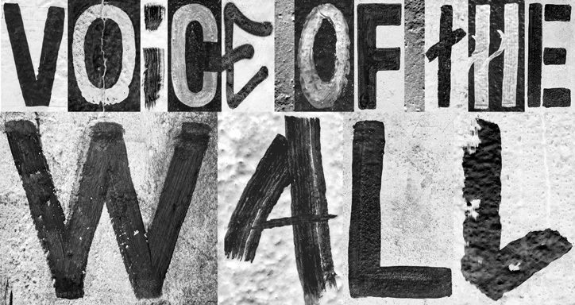
Heimat Berlin: Voice of the Wall for The Cultural Heirs | https://www.itsnicethat.com/news/heimat-berlin-voice-of-the-wall-typeface-graphic-design-121119

References:
Felshin, N. (eds.) (1995) But is it Art? The Spirit of Art as Activism. Seattle, WA: Bay Press.
González, J. and Posner, A. (2006) Facture for Change: US Activist Art since 1950. In: Jones, A. (eds) A companion to contemporary art since 1945. Oxford: Blackwell, 212-230
Lippard, L.R. (1984) Trojan Horses: Activist Art and Power. In: Willis, B. (ed.) Art after Modernism: Rethinking Representation. New York: New Museum of Contemporary Art, 341-358.
Lippard, L.R. (1997) The Lure of the Local. Sense of Place in a Multicentered Society. New York: New York Press.
Luke, T.W. 1996. Book review: But Is It Art? The Spirit of Art as Activism, by Nina Felshin; Culture in Action: A Public Art Program of Sculpture Chicago. Contemporary Sociology, 25 (5): 681-683.

https://www.liverpoolecho.co.uk/whats-on/whats-on-news/gallery/street-art-in-liverpool-12428593
https://www.bbc.co.uk/news/uk-england-merseyside-48937361
https://www.bbc.co.uk/news/entertainment-arts-35031707
https://www.liverpoolecho.co.uk/news/liverpool-news/what-happened-netflix-flamingo-mural-16056321

